GITHUB
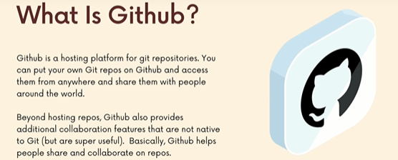
Its difficult to answer that question, cuz over the year it has add bunch of features.
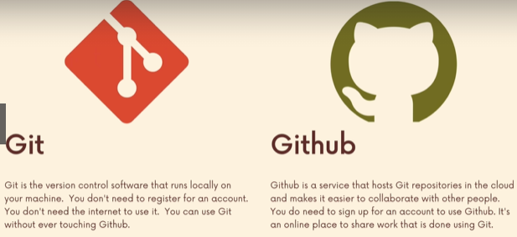

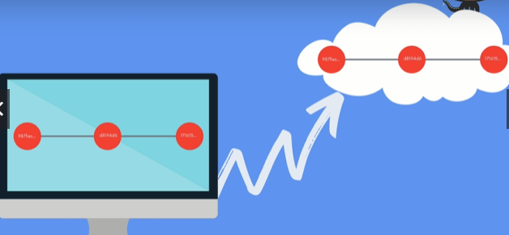

1.backup.
2. collaborate

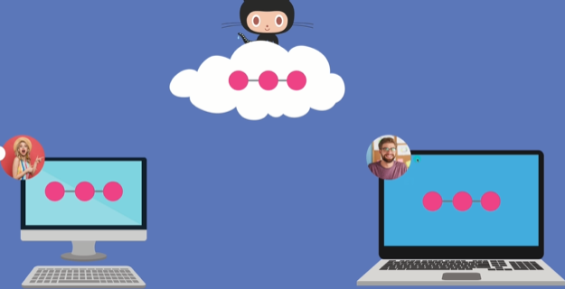
in left diagram, zelda is an engineer, and lincoln is graphic designer.

Using github they can all clone and get access to this repositories in their machine and they can make contributions and put it on github and pull their contributions.
Or commits.
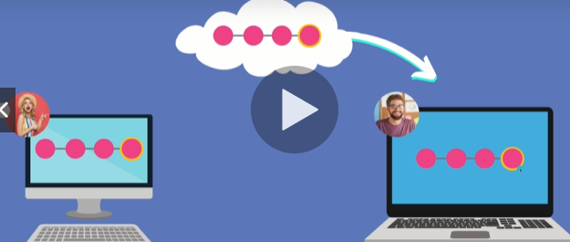



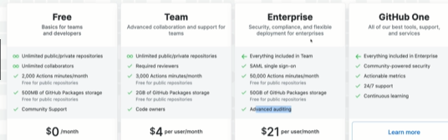

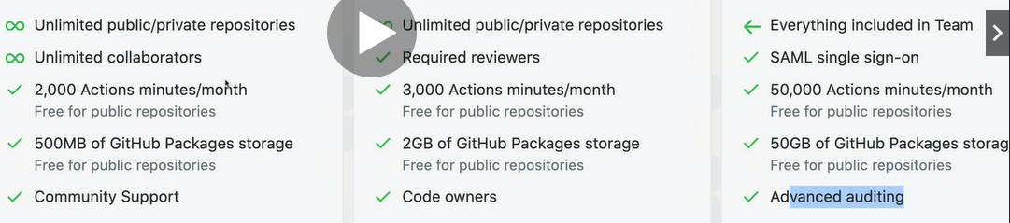
Social network for git repos, you can chat, write comments, approve , disapprove, suggest changes to projects , merge code in , reject code , call attention to certain lines of code.
Interactive developer enviorment : codespaces. Additional features like automatically scanning your repositories and looking for common vulnerbalities.
And letting you know ahead of time.

Why You should Use Github
For collaboration, backup, resume, trying to meet potential mentors.
Open Source Projects:
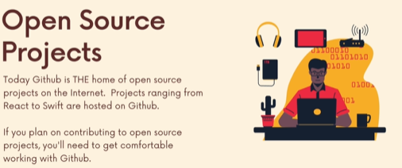

is where the codebase is available. Not just to typically (for viewing and using) but also contributions. To Fix bugs and to Discuss with greater community of ppl.
Basically the users of the product. Github is the home of Open source projects over the internet today.
Open source contribution is a great prove that you know what you doing.
For e.g: React, Tensorflow.
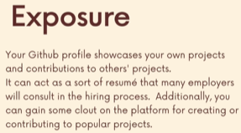

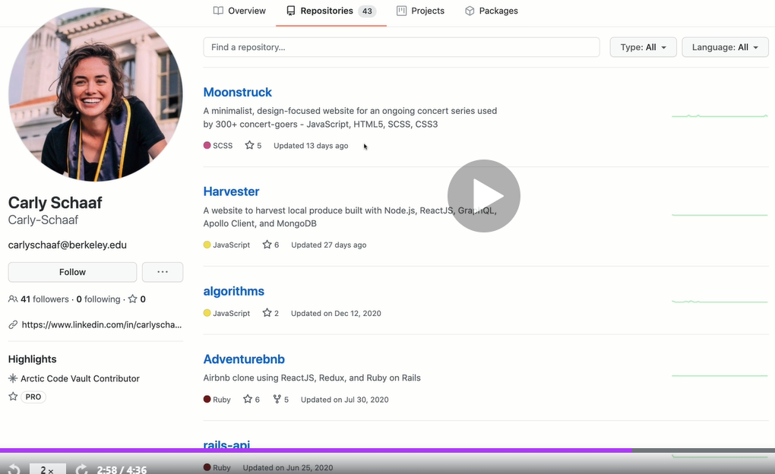
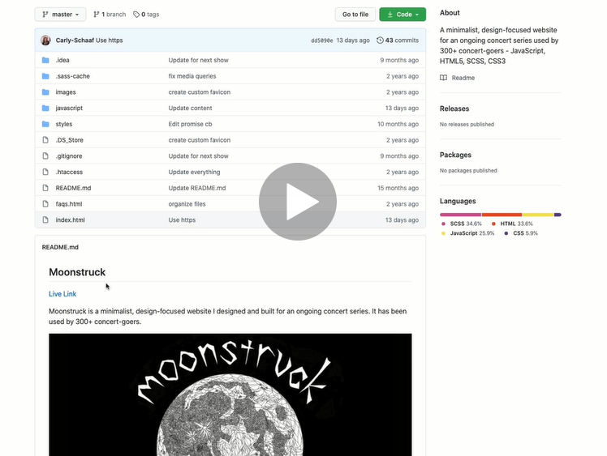

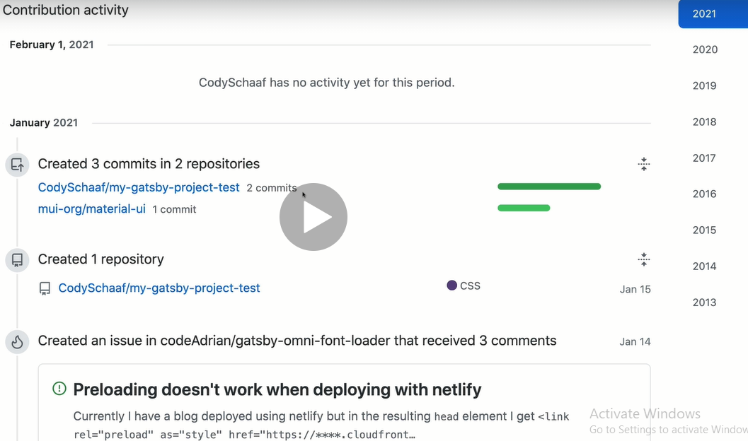

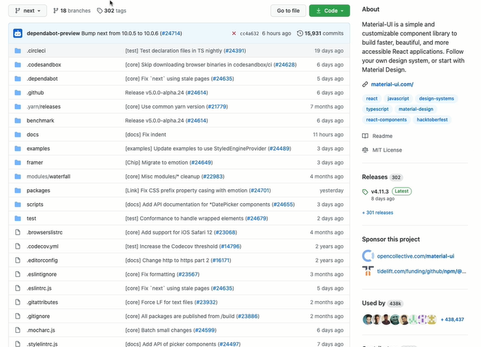

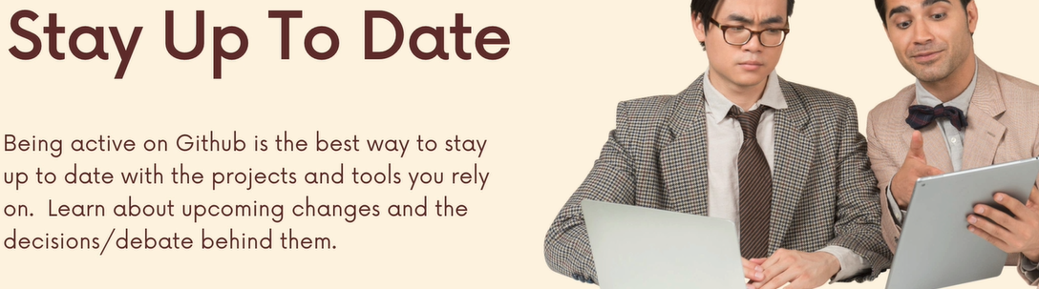

Cloning Github Repos With Git Clone
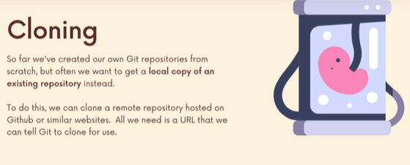

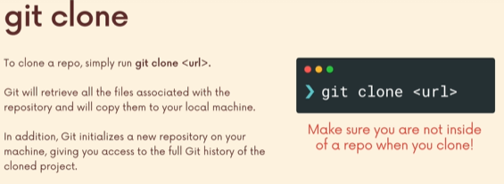
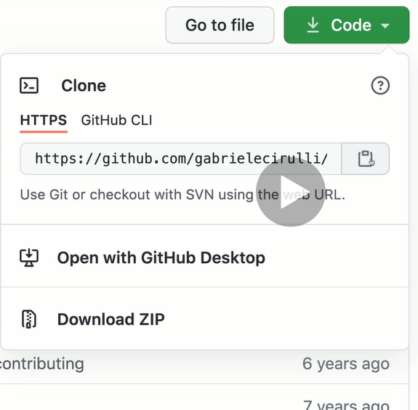

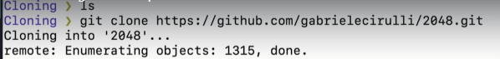
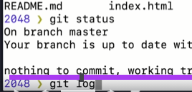

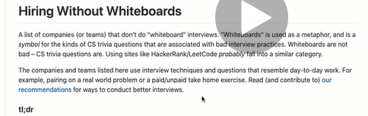

Cloning Non-Github Repos
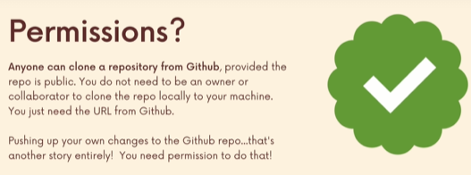

git clone works with any type of repositories.

Github Setup: SSH Config
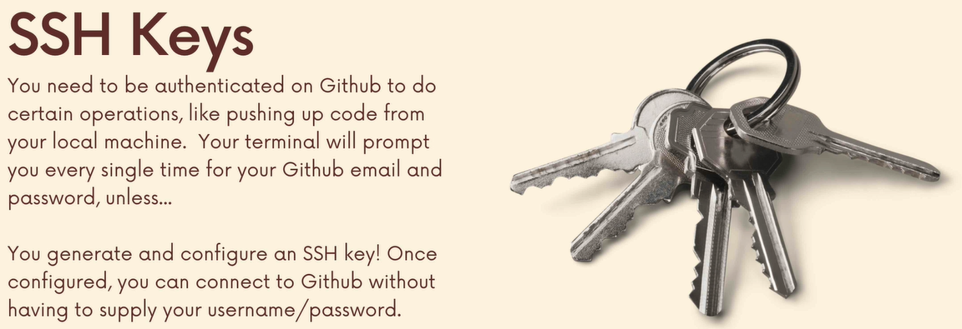

Creating Our First Github Repo!
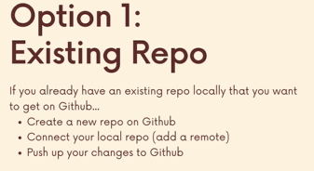

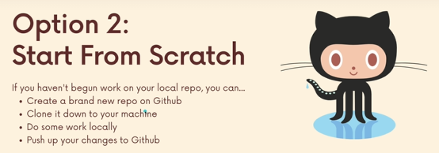
If i do that way then i dont have to manually connect my local repository to my github repository. If i clone this repo from github its automatically connected to that github url.
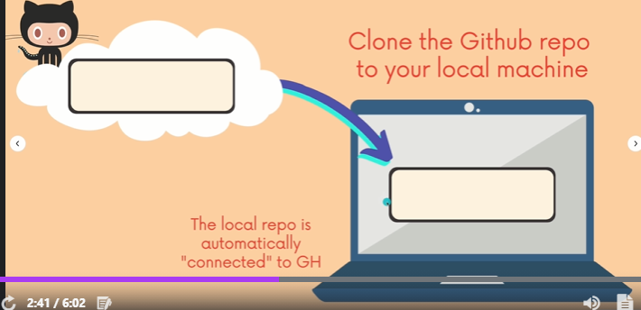

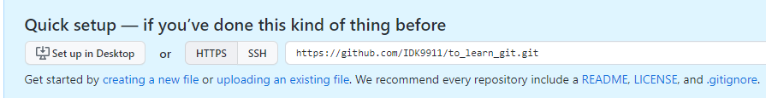
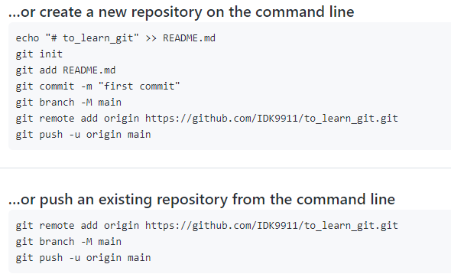
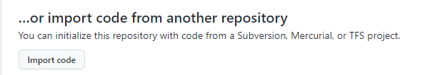

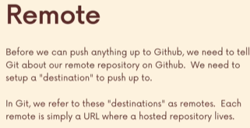
A Crash Course on Git Remotes

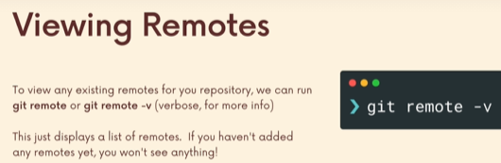

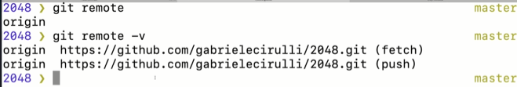
When i cloned a directory from github, i get this along with it.
By setting this url (remote) , it gives us the ability to tell is there any new code on the url, is there any new updates.
Or if i was collaborator, hey git i would like to push up my 10 commits.
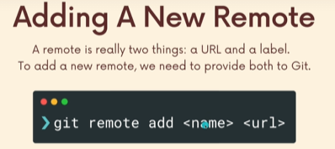

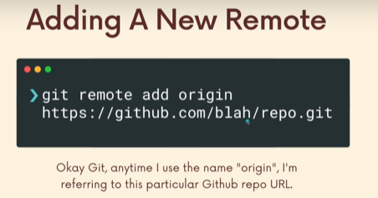

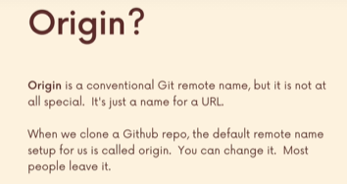

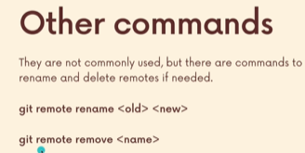

Introducing Git Push
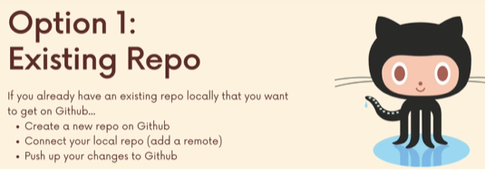

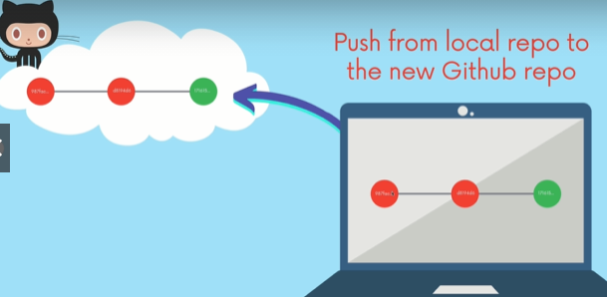

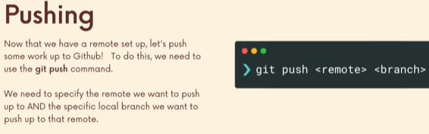
In a repository, we often have 7 or 8 branches, so when we push we may dont want to push them all on github.
Often it is master or main branch.
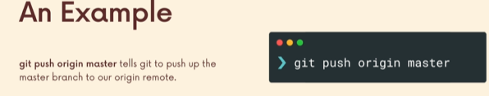
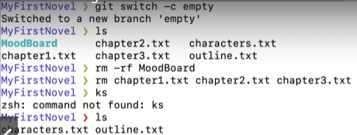

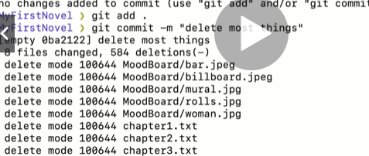

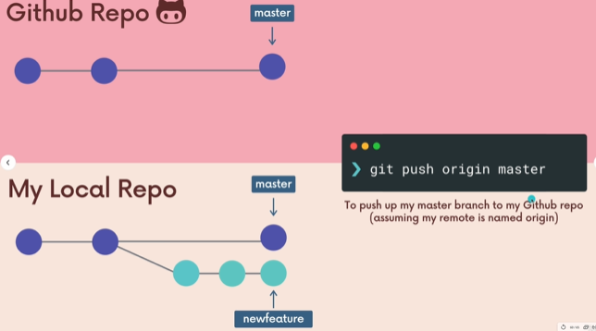

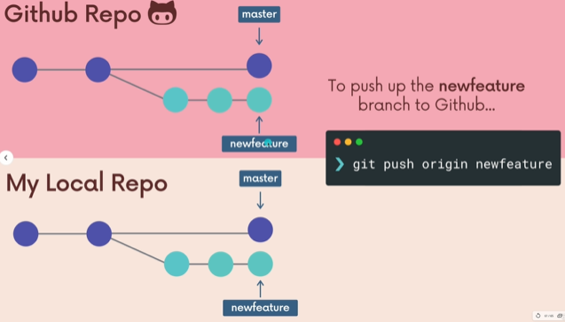

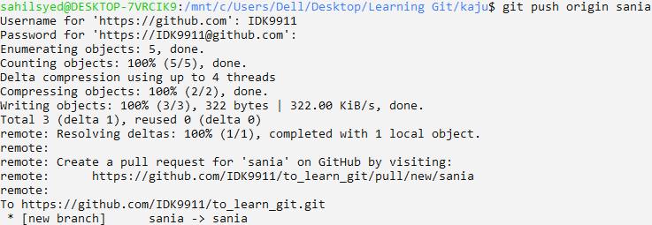
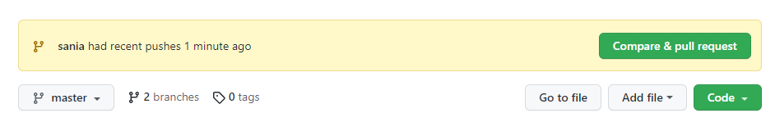

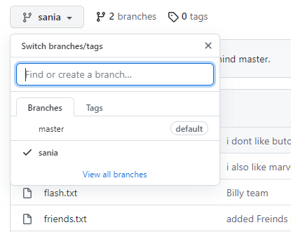

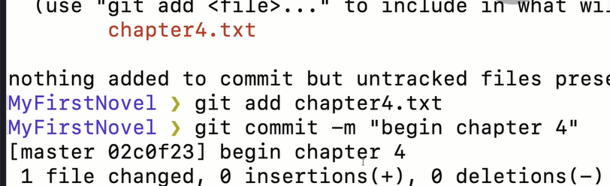

When we commit, we dont just push that commit we push the entire branch.

Touring a git repository
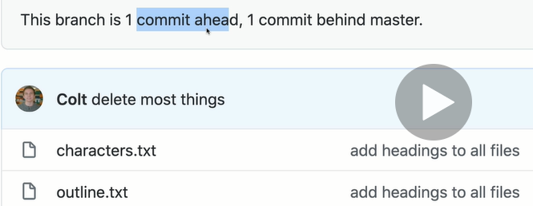

It means this branch has 1 commit that master doesnt have, and is missing One commit that master doesnt have.

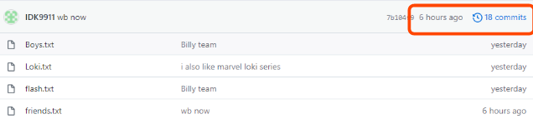
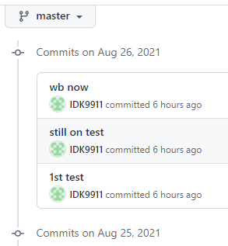
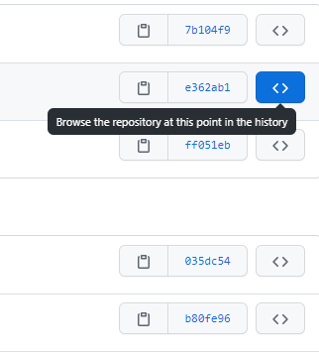

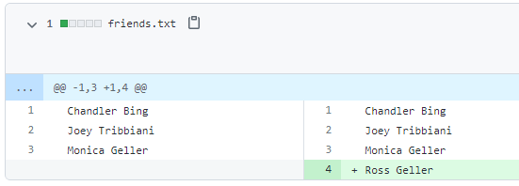

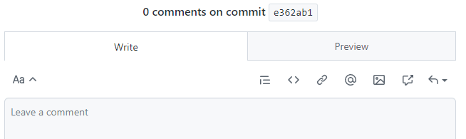
Commenting is really important. Its important for discussing changes as you start working with other people.

A closer Look At Git push
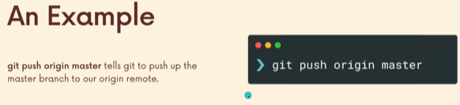

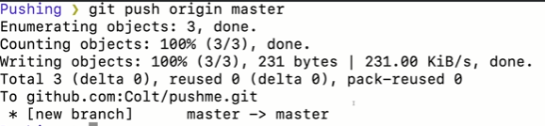
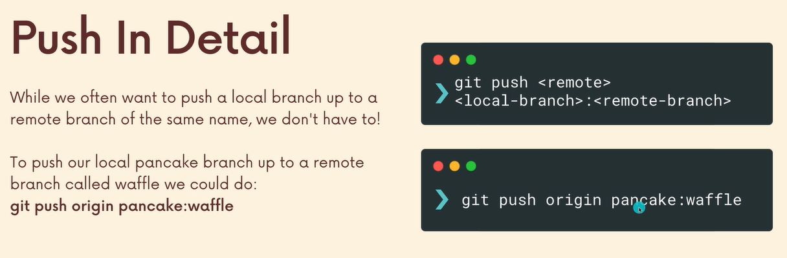
Take the local branch pancake and push it to the origin branch waffle.

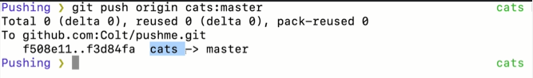

What does “git push -u” mean?
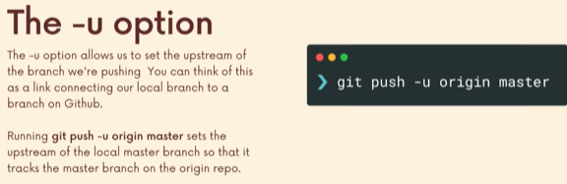
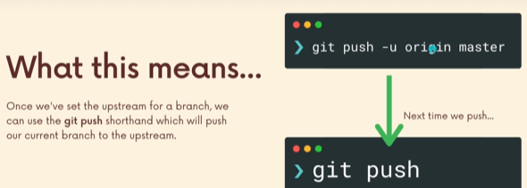
This tells git on my computer , i want to push up the master branch to origin and i want you to remember it.

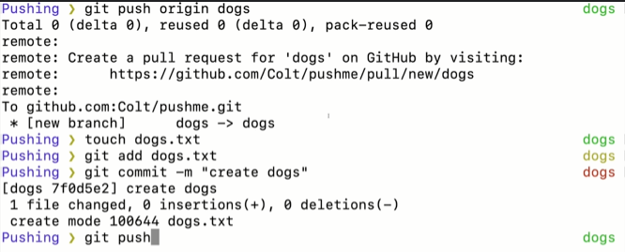
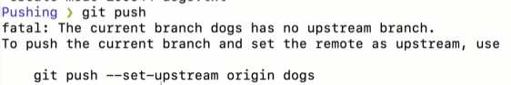
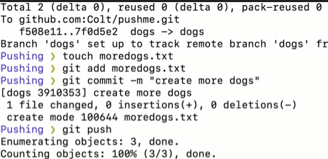

If i ran the above, not only it would make dog branch at cats on github. But it will remember this too.
git push -u origin cats.
So be careful.
Another Github Workflow: Cloning first.
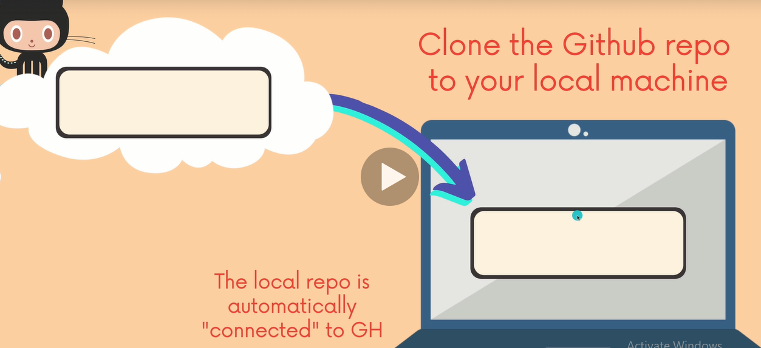
Automically do the remote for us.

Main & Master : Github Default branches
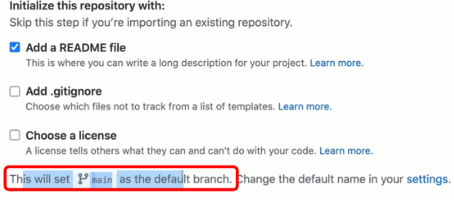
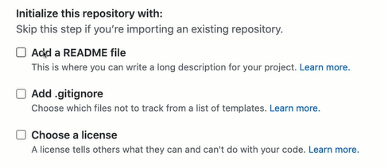

if i uncheck Readme, it doesnt say anything about Main, cuz there is no default branch.
We can change that in our settings that it always default to master.
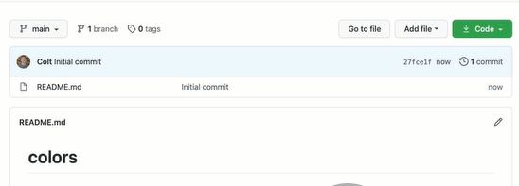

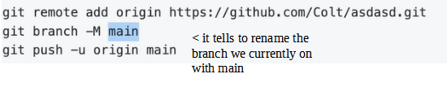

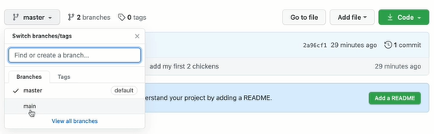

You will Still see master is still consider the default branch. Bcoz we push master first.
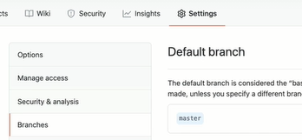

Fetching and Pulling
We are talking about remote repositories, we are talking about git fetch and git pull. They both are talking about getting changes down from the remote.

Remoting tracking branches : WTF are they
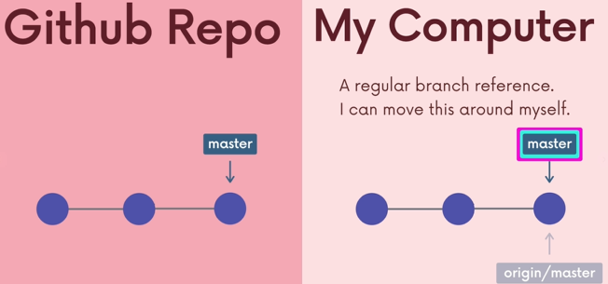

Whatever the github repo as its defualt repository, we gonna have that, in this e.g its master, we gonna start with that as our default.
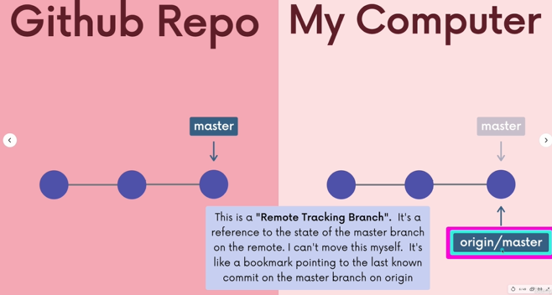

master and origin/master may start form the same starting point, but they might diverge as we do more work aka commits in our local repository.

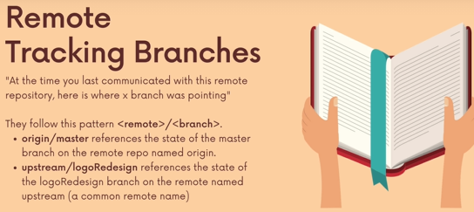

Think of remote tracking branch as the last time you communicated with this remote repository. Here is where, the master branch, pointing at the github repository.
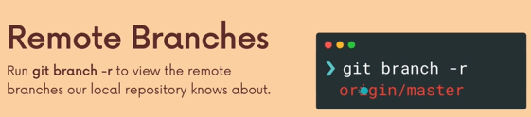

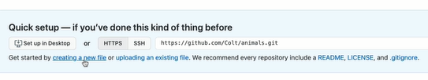

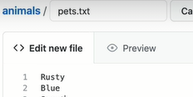
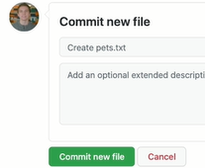

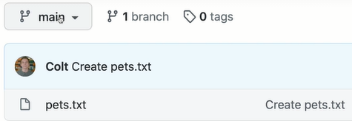

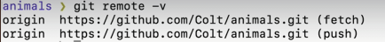
above, git setup this remote tracking branch called origin at Main.
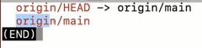

Checking out remote tracking branch
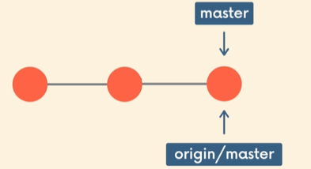
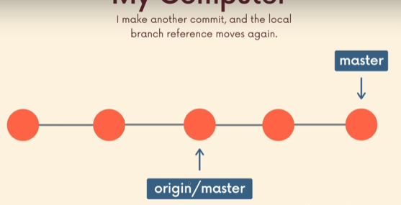

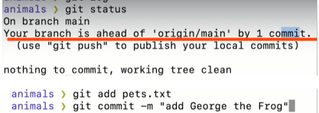

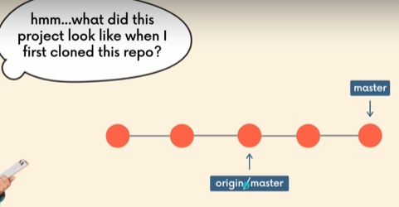

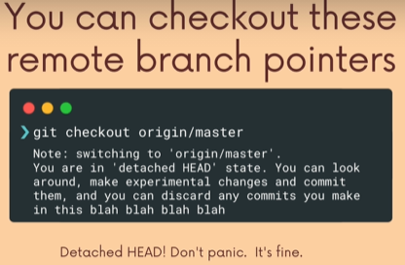

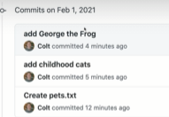
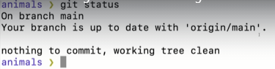

Working With Remote Branches
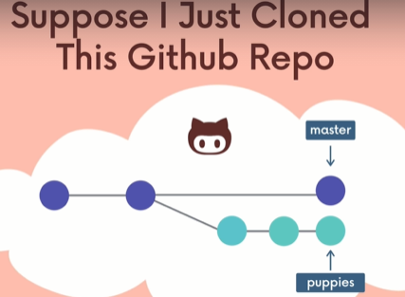

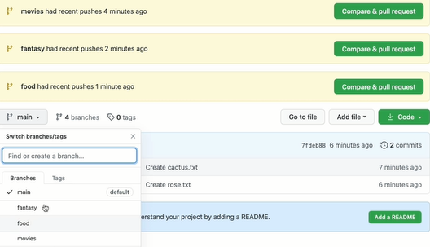

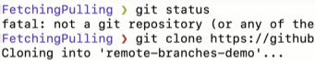



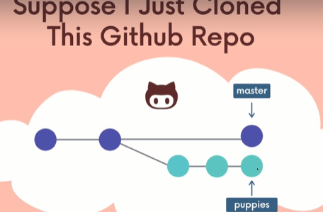
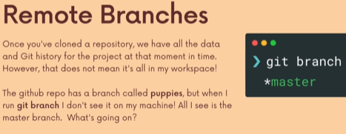

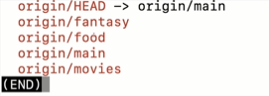

We see everyone of the branches, it has a remote tracking reference. It can tell me where each one his. Just like a bookmark.
Below, but we don’t see the branches.
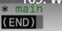
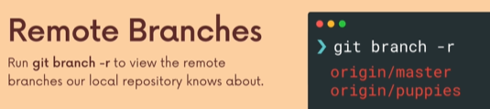

Whenever we clone,
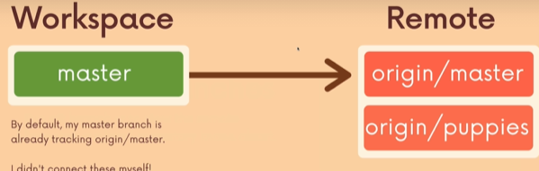

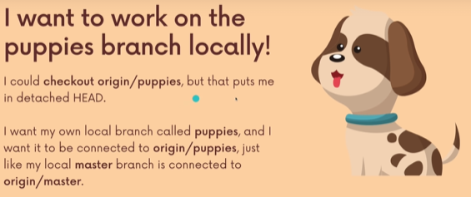

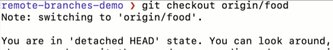



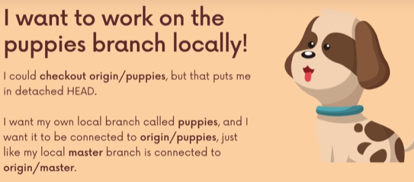

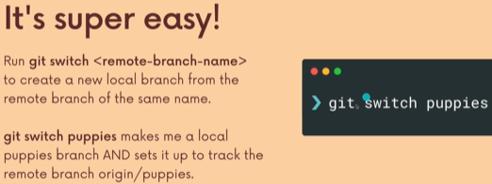

So if we switch to a branch with that exact name, so if git detects that we are switching to a branch puppies which doesn’t exist. It will check then remote branches in the repositories and will make the connection.
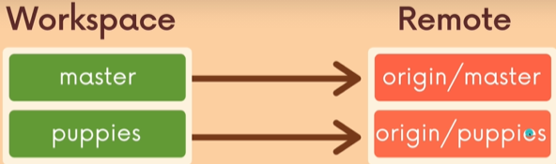

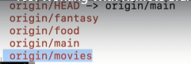

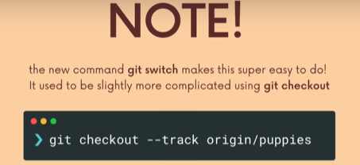

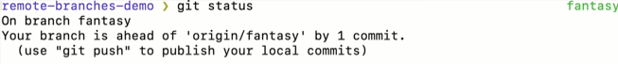

Git Fetch: The Basics
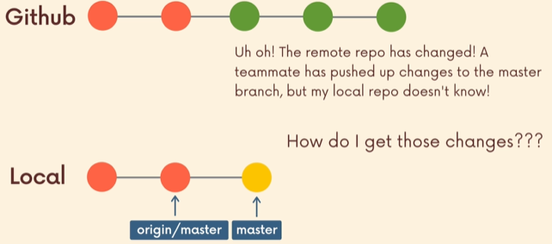

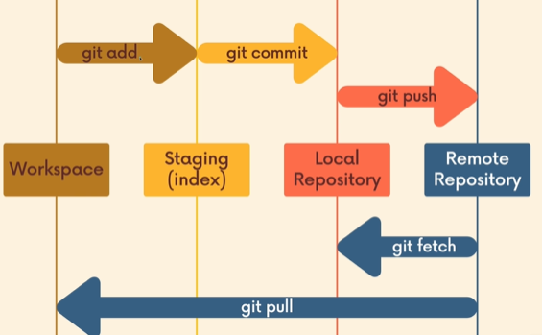

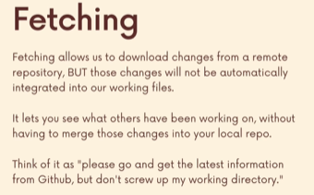

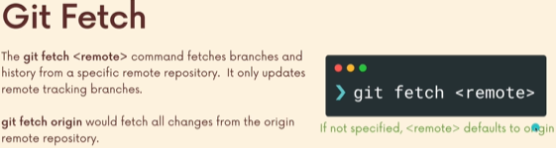
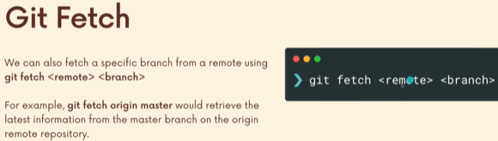

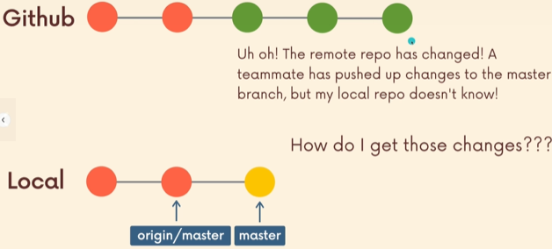

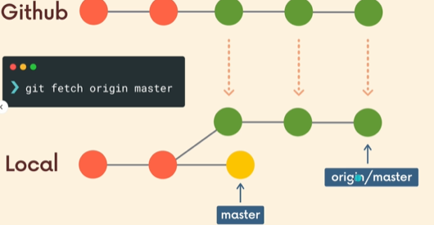

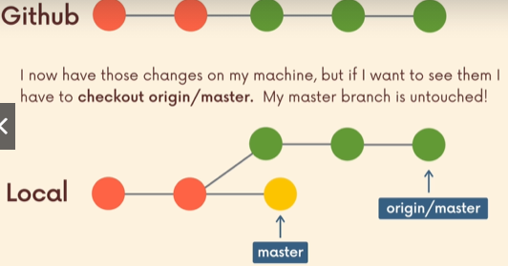

Demonstrating Git Fetch
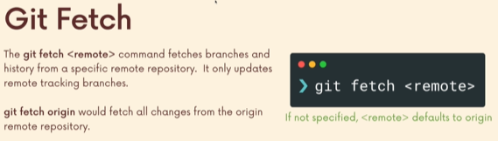
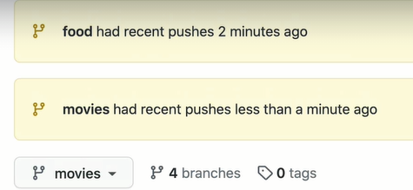

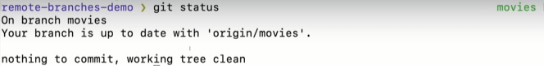
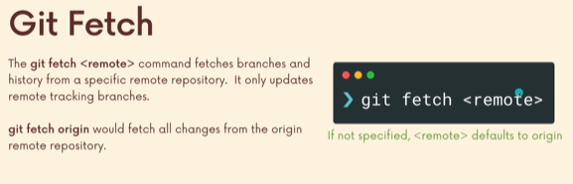

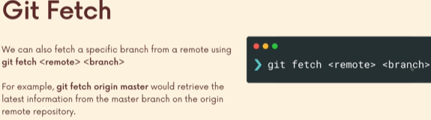

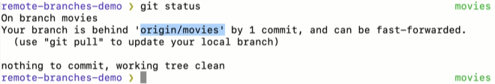

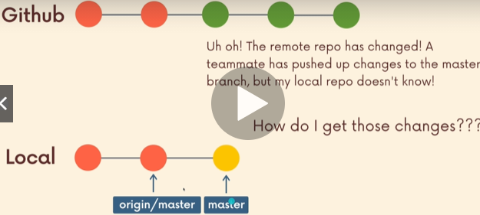

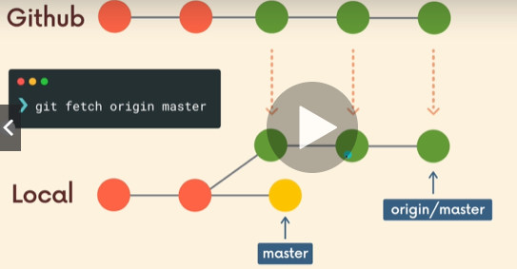

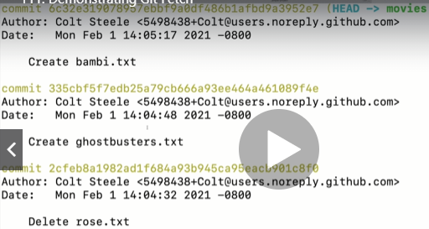

You don’t see anything new.
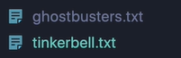

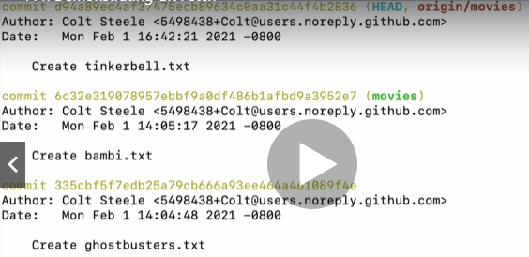

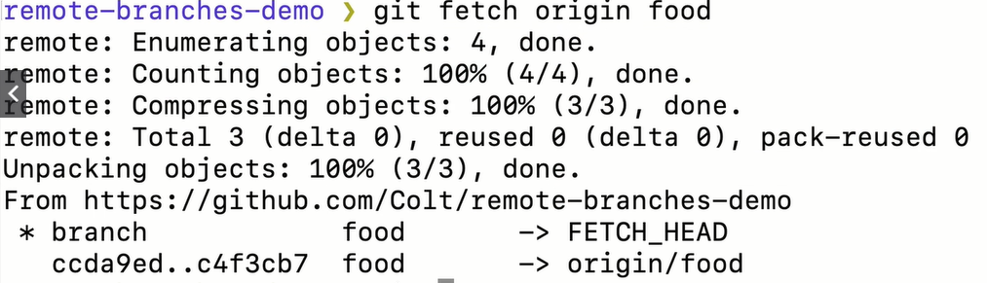
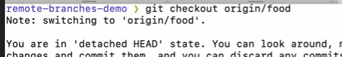

Git fetch is not just about updating the particular branch that you are on and getting the latest. Also it might be that new branch was created.
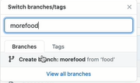

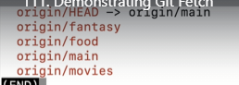
I don’t see morefood.

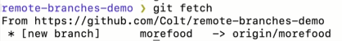

Git Pull
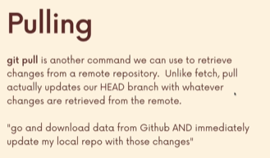

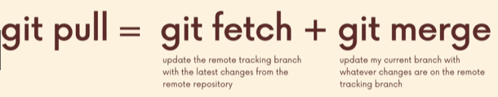

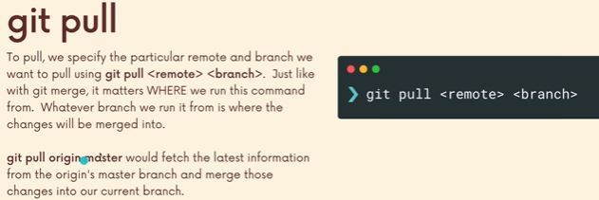


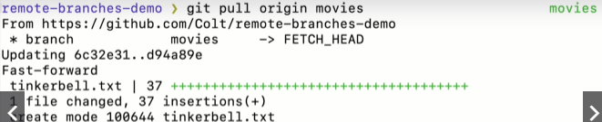

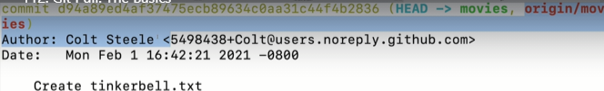

Git Pull & Merge Conflicts


Sometimes you may have some work locally, that is not on github and github might have some commits that you don’t have locally. So when you pulled down there is gonna be conflicts.
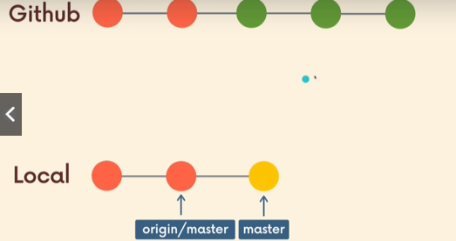

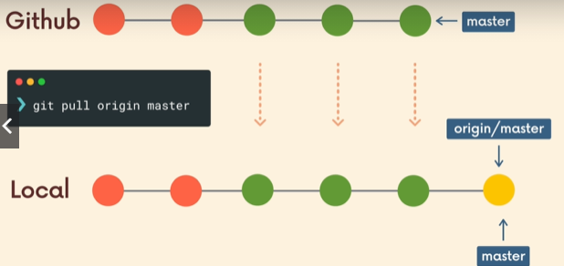

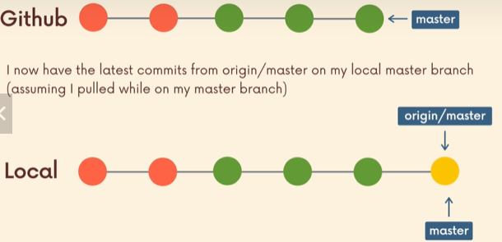

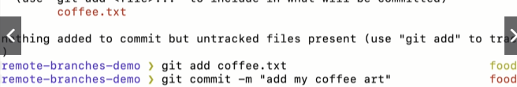
Good practice, before you push anything on github, you might wanna pull down and see if theres any change.
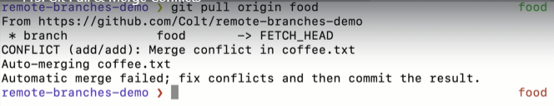
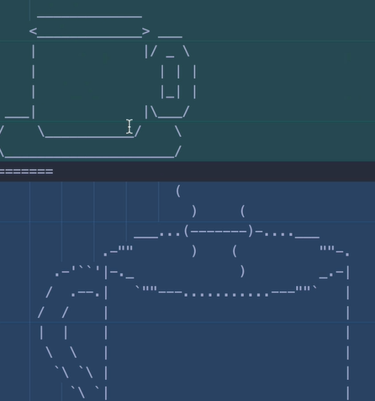

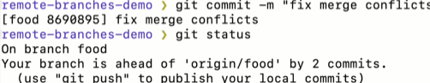

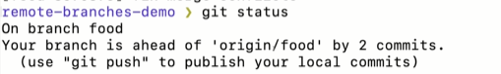
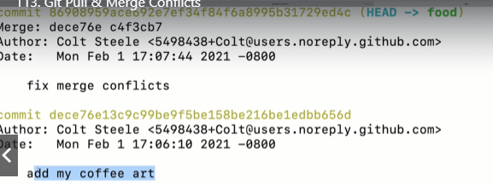

The reason its ahead, the add my coffee art was my first commit( which was local).
The fix merge conflicts when we pull the github commits and merge them with our locally committed changes.
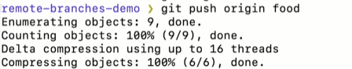

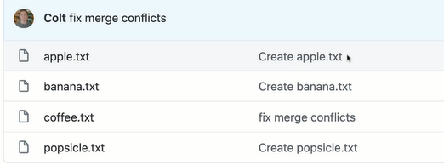

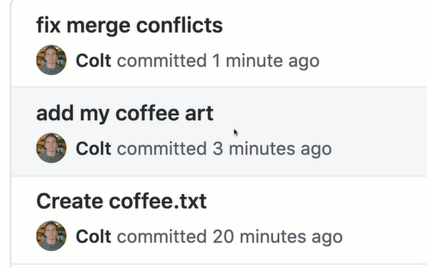

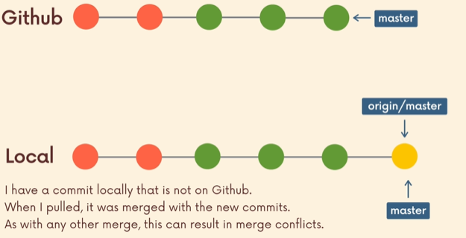

A shorter Syntax For Git Pull
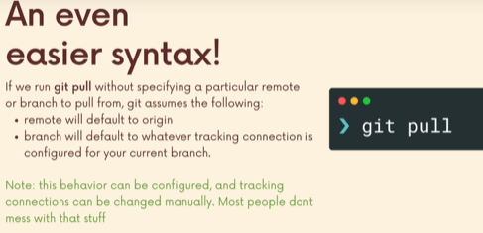

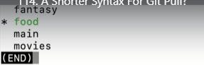

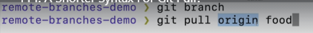

We never setup the tracking connection.
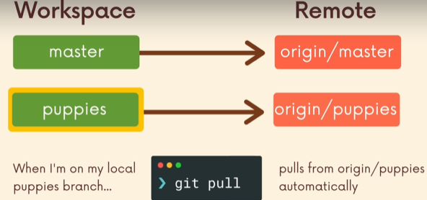

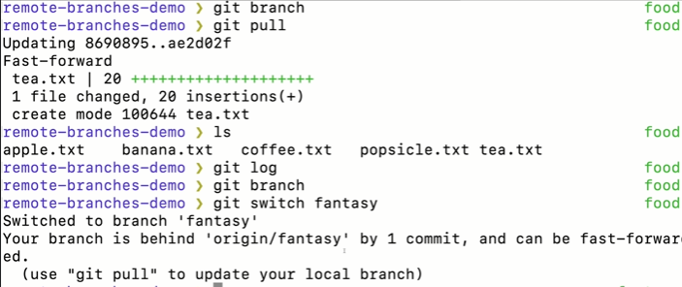
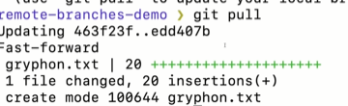

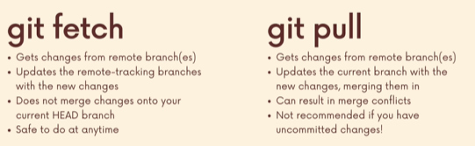

Github Grab bags Odds and ends
Readme.md , Md stands for mark down.
Github Pages, a very nice tool from Github that allows us it helps us to easily host static web pages from our repositories.

Github Repo Visibility: Public vs Private
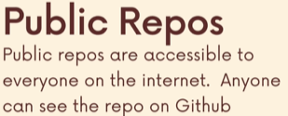
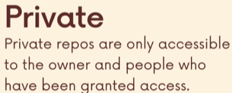

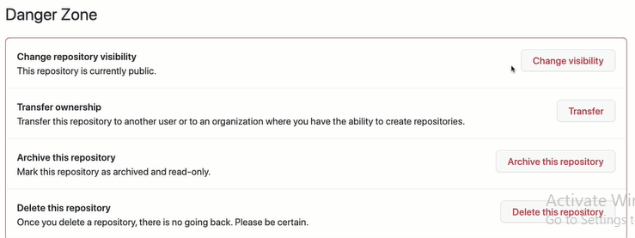
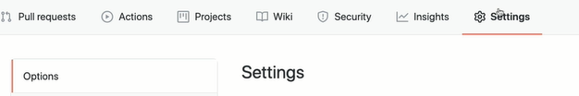

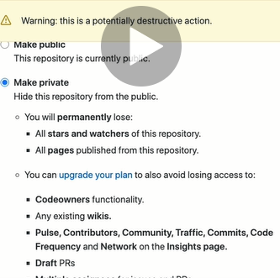

Adding Github Collaborators
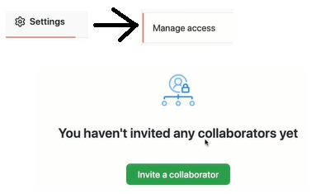

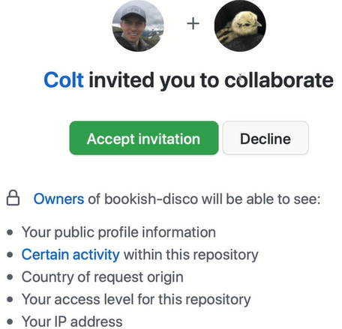

Github Collaboration Demo
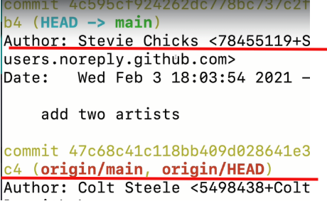

stevie will push the changes to colt github. Since stevie is a collaborator.
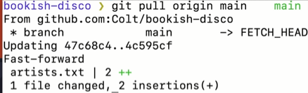

What are READMEs?
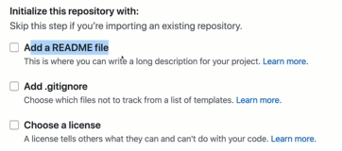

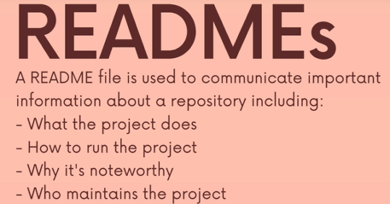

What your project does, whether you working on some API, or some Web Applications, video games. Even if you r just government using github to make law legistativley.
Whatever your repos is, the readme file should include information about what the project does, what its for, who is it for. How to get started with ur project. How to run and install dependencies if necessary. Why its noteworthy. Who maintains the project, how to collaborate the project, how to get help.
Not everything needs to be there. But if there is important info that you need to convey.
Somebody comment to your project for the first time, then put it in the readme file.
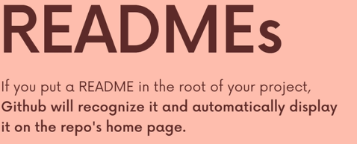
It will render

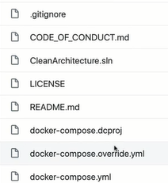
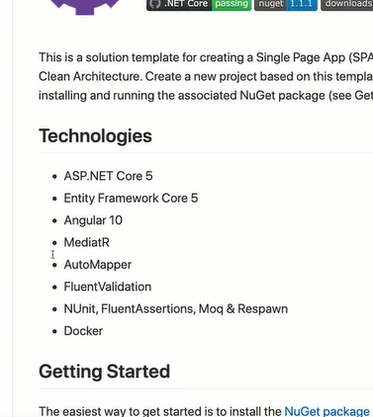

List of technologies.
How to get started
How to configure
How to configure db
How to migrate.
Support
license

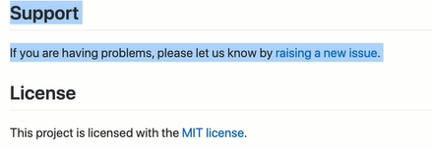

Link for above: click

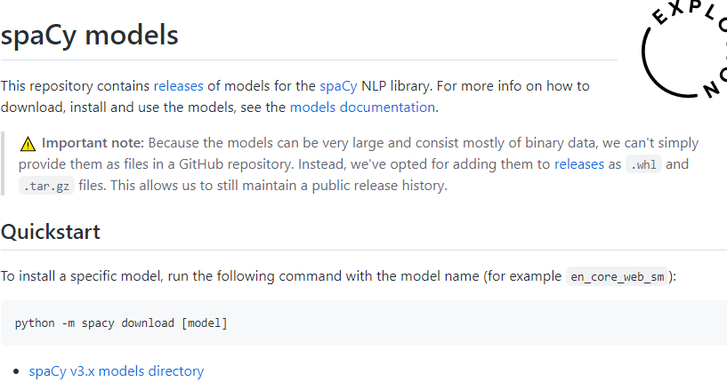
Link: Click

Readme file always place at root of your project always. Sometimes .git folder.

Link: Click
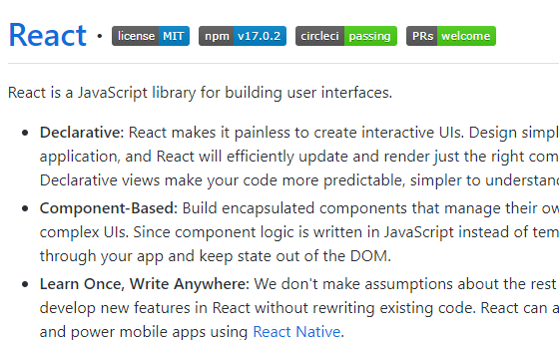

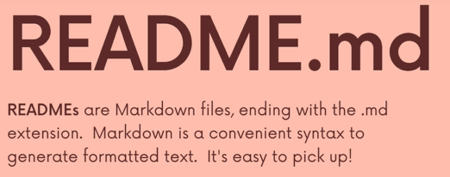

A Markdown Crash Course
Link:Markdown webpage
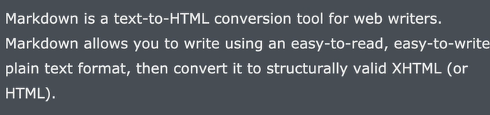
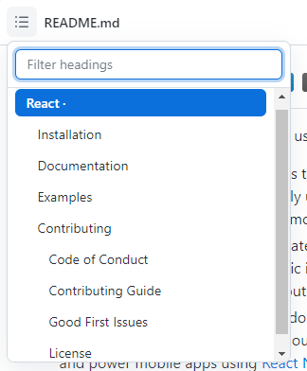
← how much structure is important.

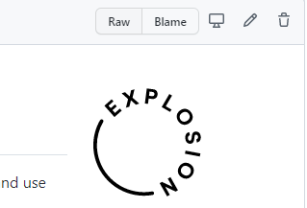

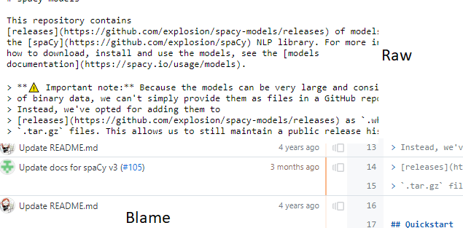

Link:Markdown-it
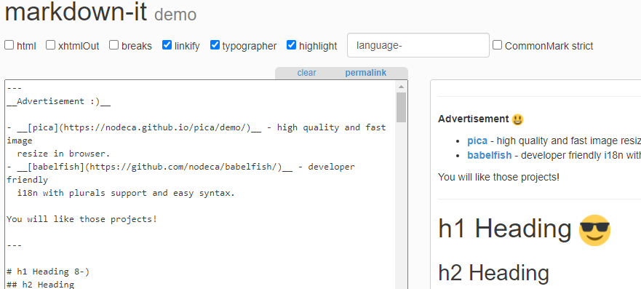
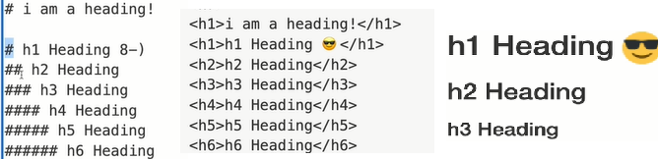
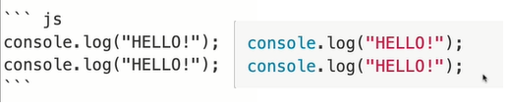

Reddit use markdown.

Adding a ReadMe To a project
Alot of time, you working on a project. You don’t expect for anybody to ever see it.
They are the probably the one thing, that a recruiter or a non technical person would see, if they are looking at your projects.
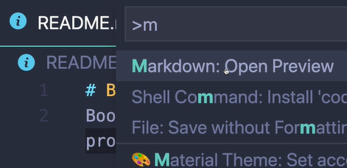
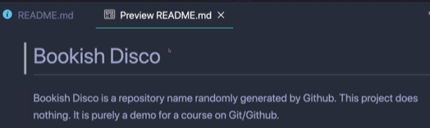

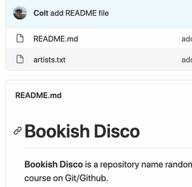

Creating Github Gists
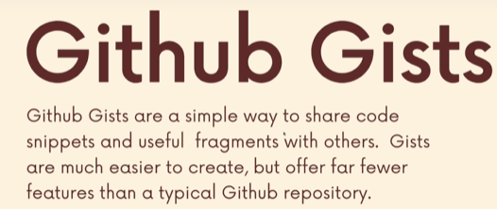

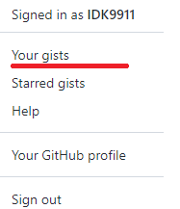

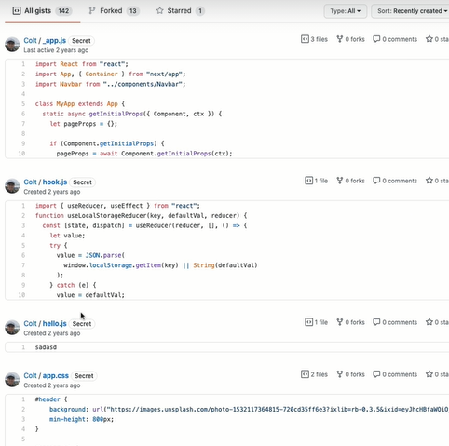

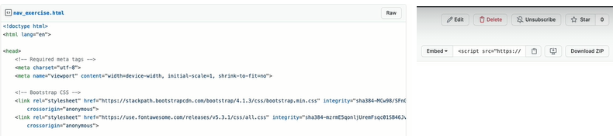
The ability to leave comments, I can personally delete this file, edit this file. I can download it and share with people, fork it and star it

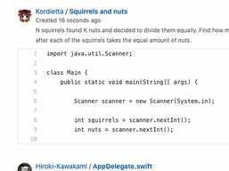
All gist
You can see gist what other people have made.
So they range from mark down files.
We use git for teaching and share stuff.



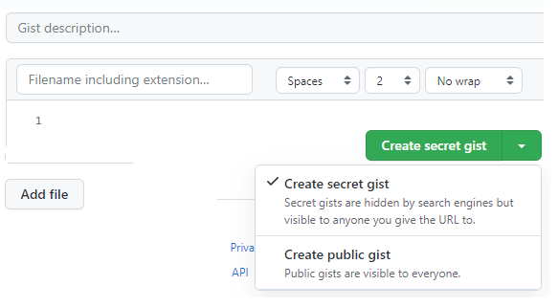

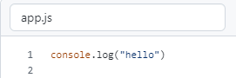

Introducing Github Pages

Link: Click

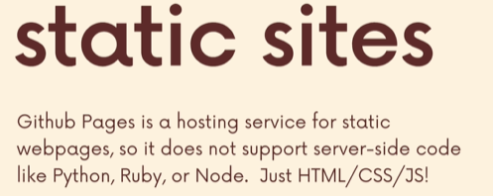

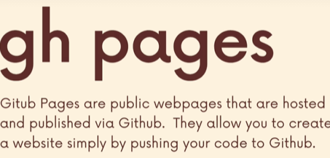



For static web sites, for portfolio websites or documentation website for your repositories. If you build a js game , you can use github pages to host that.
You don’t expect github pages for high capacity web traffic. Its not really meant for that. Its free and its built for github.
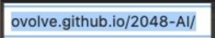

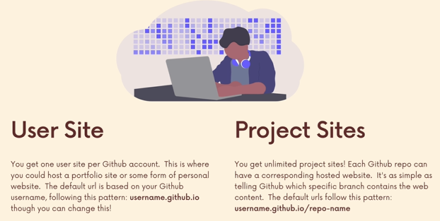

Github Pages Demo
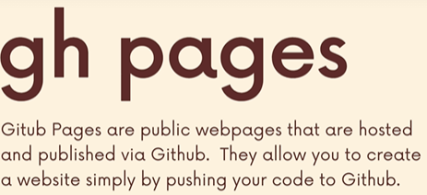

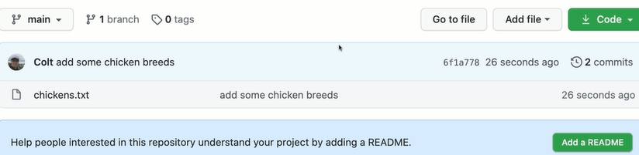
Now , if I have to setup github pages website, all that I have to do is select some branch, I am gonna tell github contains a website.
Its gonna look for a file name “index.html”

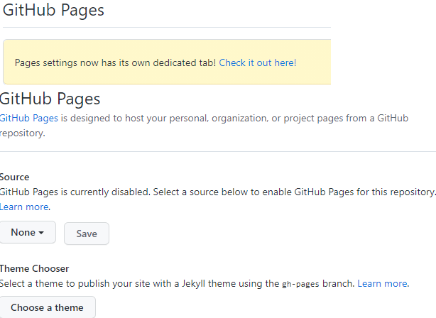

You can setup your website on any branch whether its main or not.
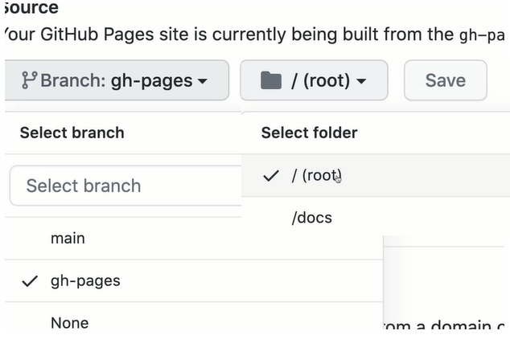


gh-pages are standard defualt names.

Git Collaboration Workflows
Different ways of configuring repositories, differents ways of working on branches, When to create branches, how to merge changes, how to ask to merge changes How to get permission.

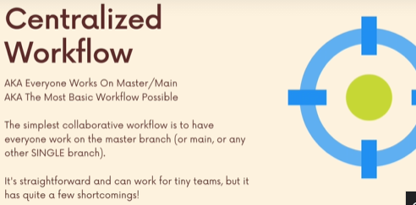
The Pitfalls of a Centralized Workflows

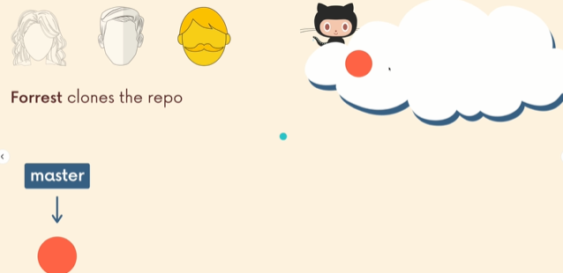

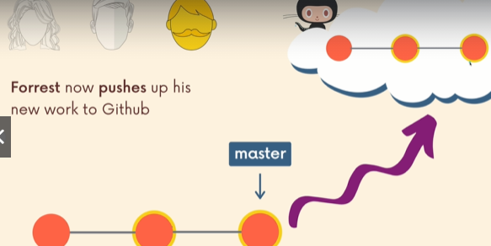

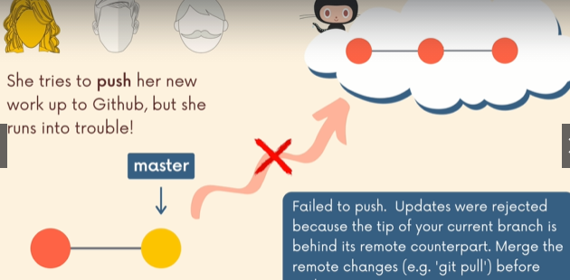

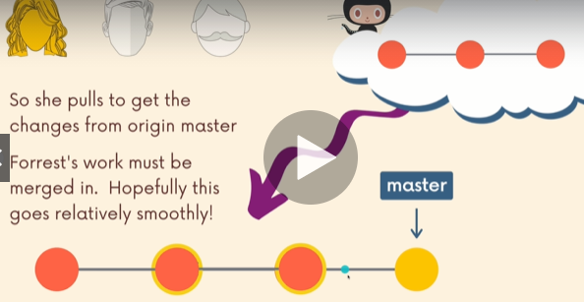

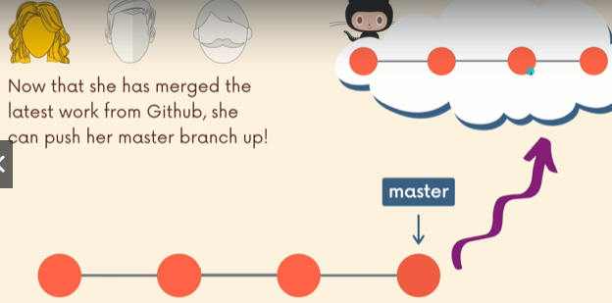

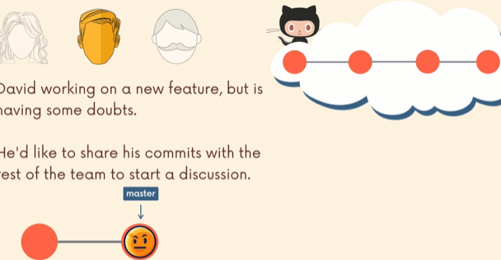

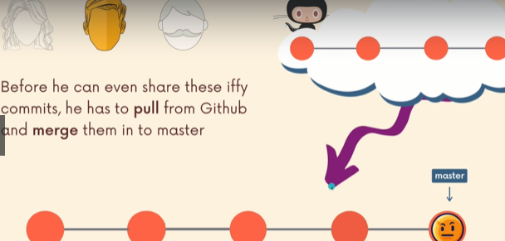

if this is incomplete, so everyone has a incomplete code. He broke the codebase.
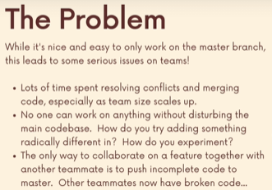

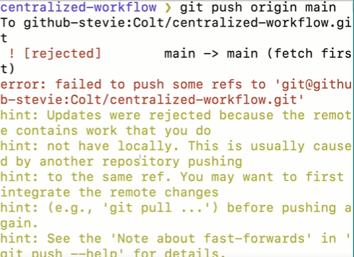

Above is Central workflow problem. Stevie is tryna push is broken code in the master branch while his fellow coworker has already made commits on the remote repo. So stevie is behind some “n” commits. In order to show his coworkers and start discussion he has to merge “source of truth” or “official branch”.
Leading to “broken code” at “source of truth”
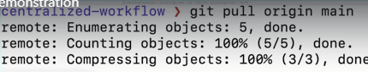

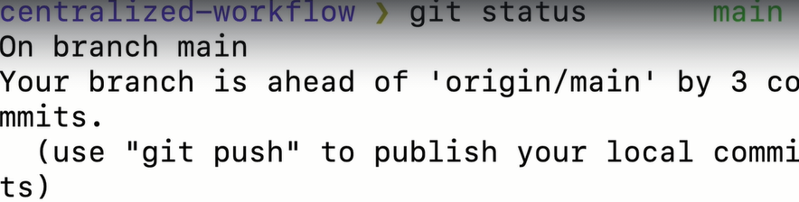

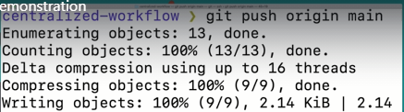

Next day, colt receive changes from stevie to help with his code.
He has changes in his local repositories which arent commited.
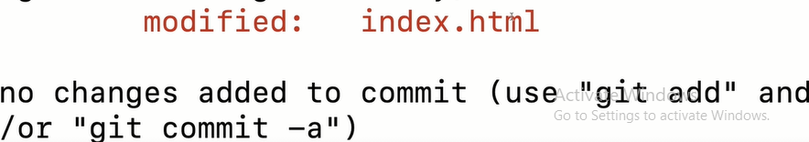
He needs to stash those changes, since he don’t wanna commit yet.

The All-important Feature Branch Workflow
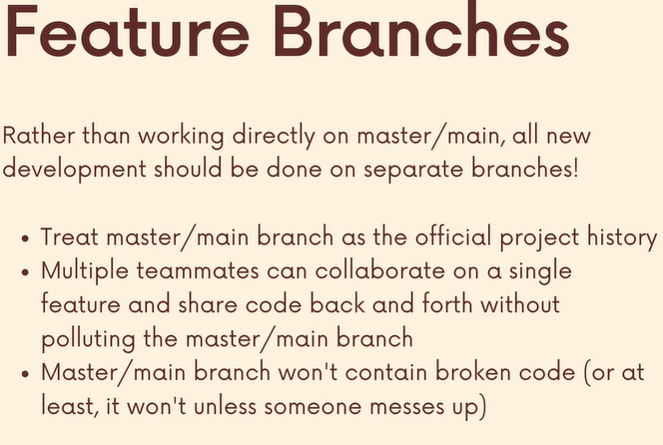


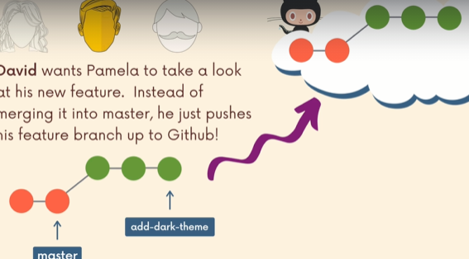

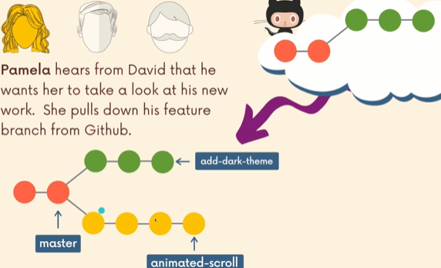

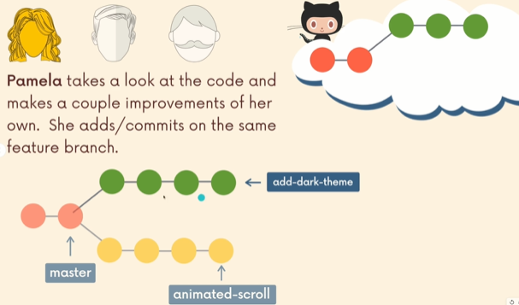

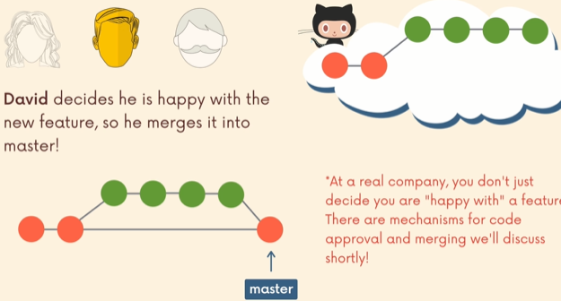

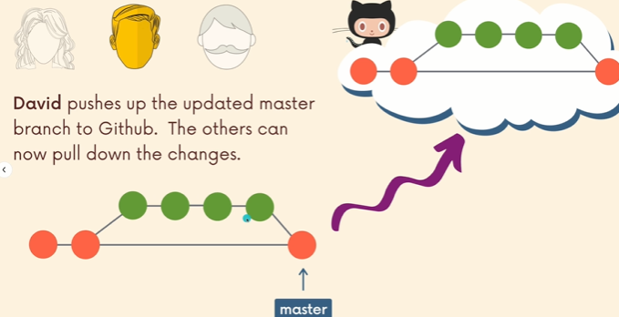

Feature Branch Work Flow
We havent really talk about naming feature branch in general. For e.g
feat/navbar <!-- By feat he meant features
bug/navbar
fix/navbar
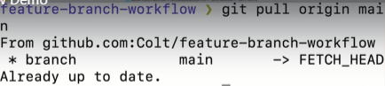

Its always a good idea, to see is there any new commit. If there is, you can start your day with fast forward.
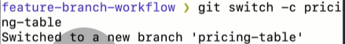

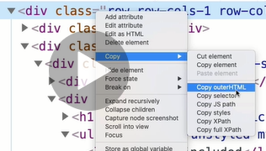

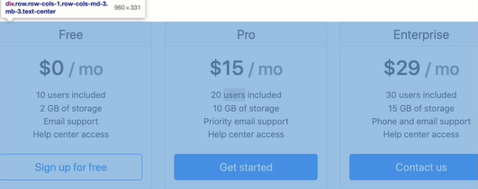

Everytime you make a feature branch, you don’t have to push into github.
Alot of time , you wont do that. Unless you have a particular reason to share it to somebody.
If you look at organization repositories, they are not gonna be 1000s of feature branch. Even though there have been 1000s of feature branches over a couples of months.
Alot of time, we remove then.
Alot of time, we merge it to master or main sometime or delete the branch when you done.
To see if ,Has anything changed.
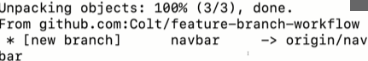

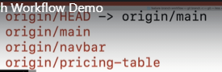

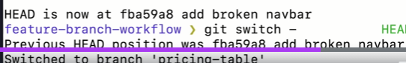

i need to leave detached head.
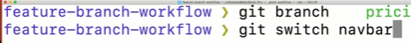

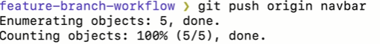

Merging Feature Branches
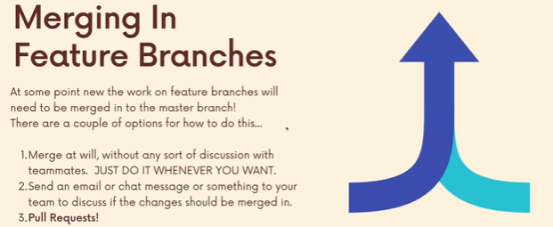

Delete the branch after merge if we dont need it anymore.

Introducing pull request
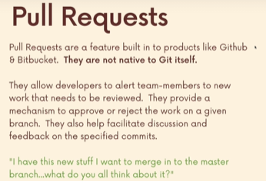
So if you are in a company where the stakes are high, where you cant expect to screw up something in the main or master branch.
What if somebody did a bad commit or something that break the main branch. At the very least, you’ve got 100 more developes who now have a bad version of that main branch and they have to get rid of commit or reset it.
Its just annoying.
You want to make sure that whatever you are merging in or whoever is doing the merging has some discussion around it, has some approval.
Maybe changes are made at the request of somebody else.
There’s some code review process involved and pull request are integral part of the process.

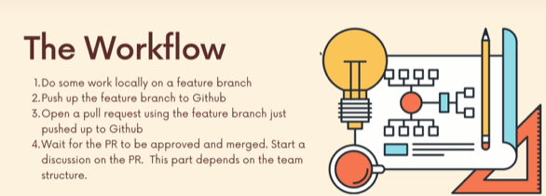
Maybe multiple ppl have to approve.
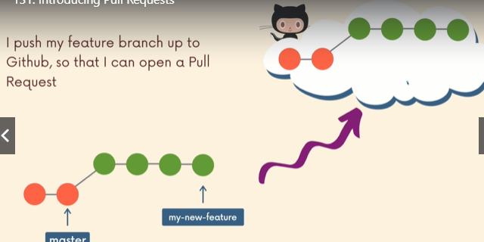

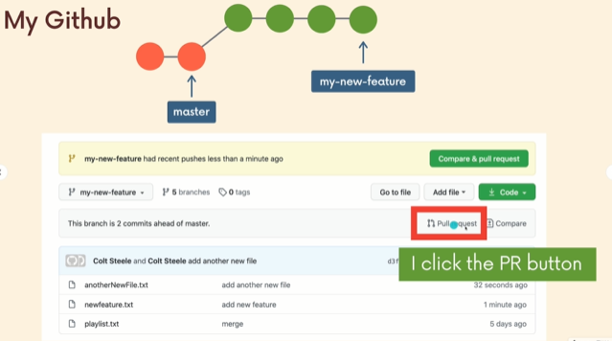

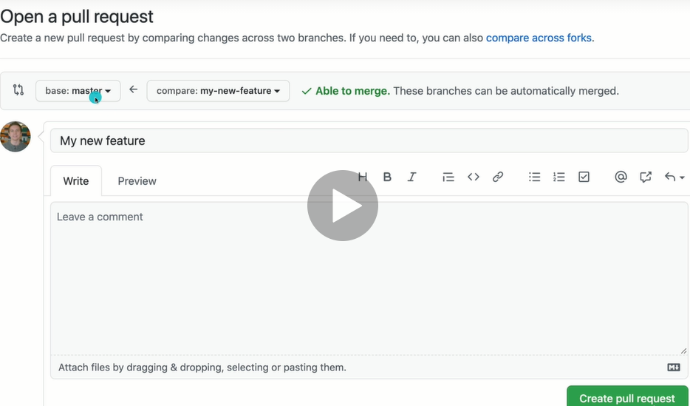
I am requesting my-new-feature to merge into master.
Then i need to provide some information, i need to come up with what my pull request is. Whats the reason for it. What does it includes. Depending on the company and organization. Theres gonna be pretty strict rules for what goes in here.
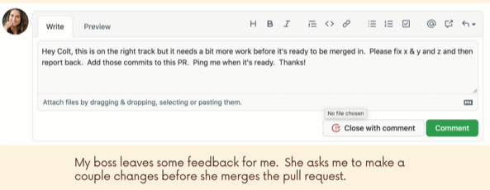

I as an employee dont have the ability to merge directly into master in github. I am supposed to make a pull request.

My boss find some issues, leaves me some feedback. She asked me to make some changes, ping me when its ready. I can notfiy ppl and mention ppl in comments and i can attach files and she can also just closed it, its kinda blunt way of saying no.


Colt: hm, r u sure you want me to do that. Whats the motivation and im not sure that i agree with that. What do u think, other developers. I can bring somebody else in and can have a full discussion on the team.
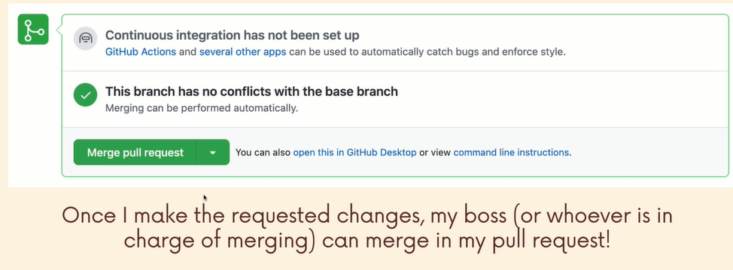

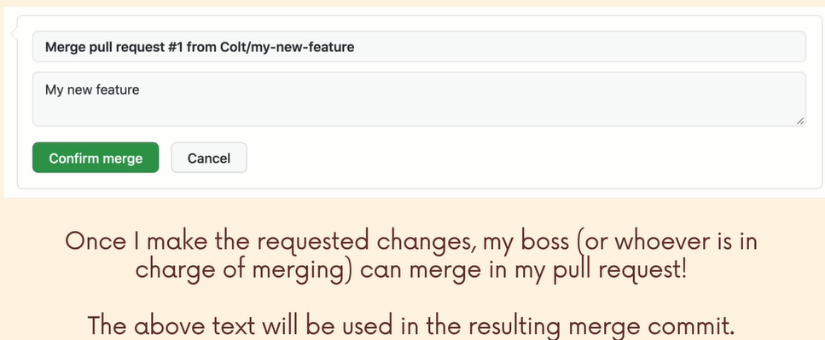

Making our First Pull request
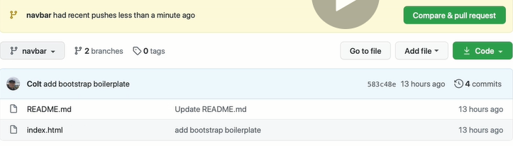
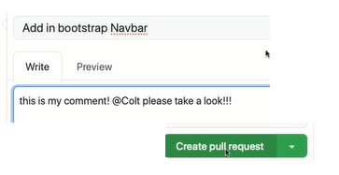

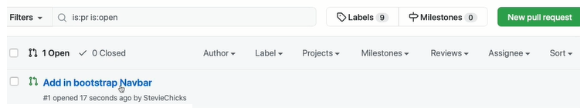
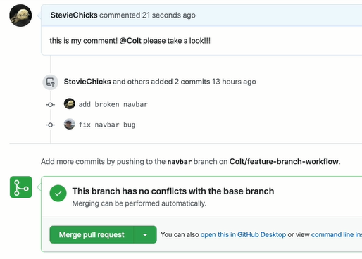
We see, Stevie has the permission to merge it in.

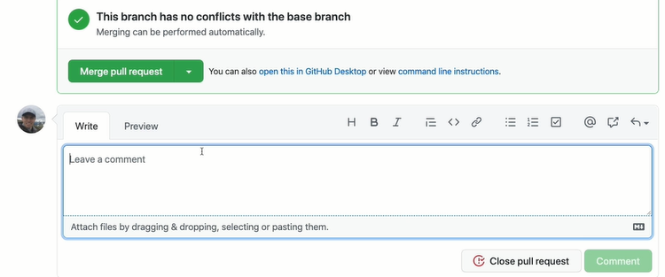
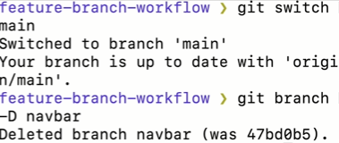

Merging pull Request with Conflicts
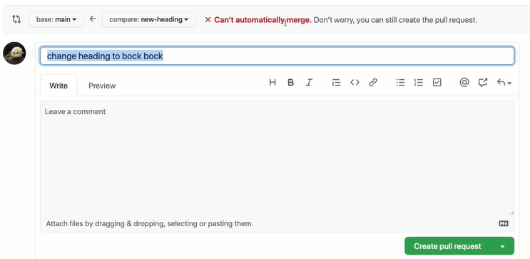

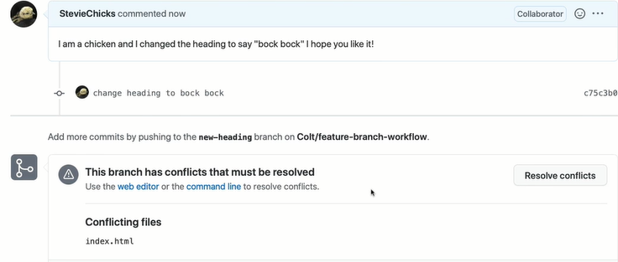

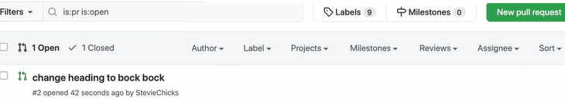
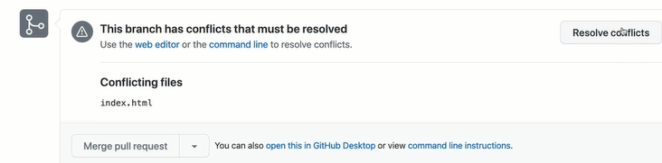
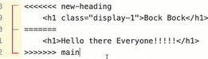

Or
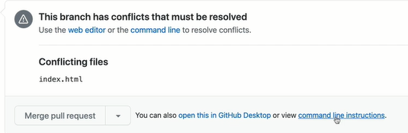

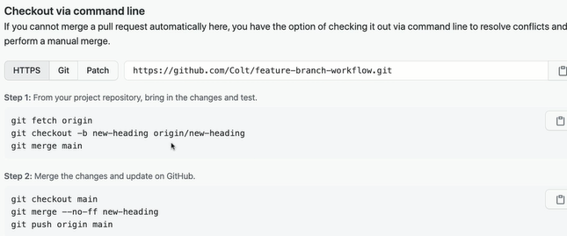
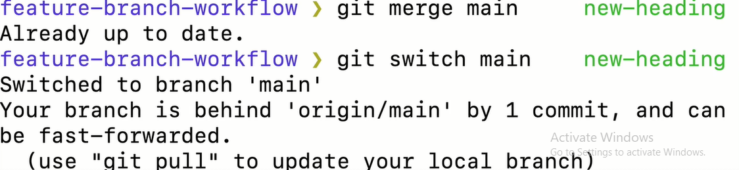
It return already up to date, since we didnt know main has been changed. Thats why git fetch origin was given above.
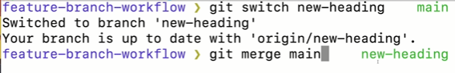
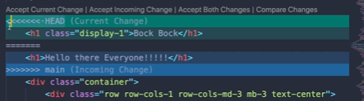

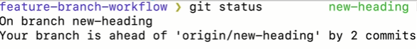
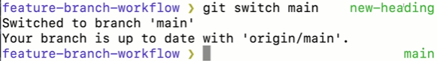
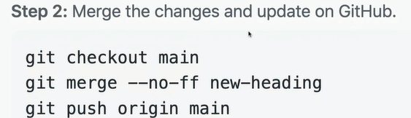
--no--ff that’s an indicator we telling git merge to not to fast foward, if it detects it can.
Bcoz when we do a fast foward, instead of making merge commit, it will move the branch pointer to some new commit. Sometimes you wanna prevent that from happening especially when we want to maintain a specific branch.
We want to make it clear that there was a branch merged in here just to have that history.
You dont have to do this part, but it s what github recommends.
Above , made 100% sense kazim.
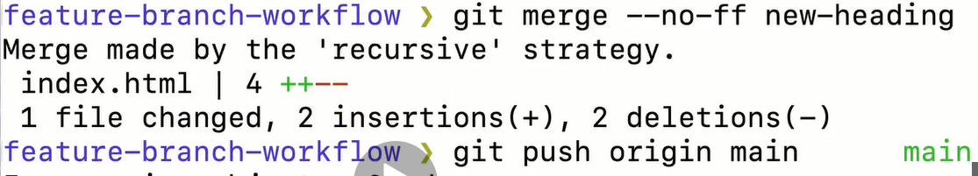
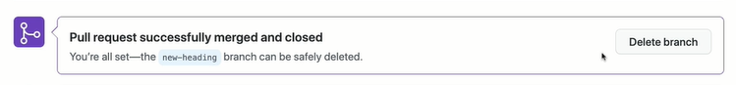

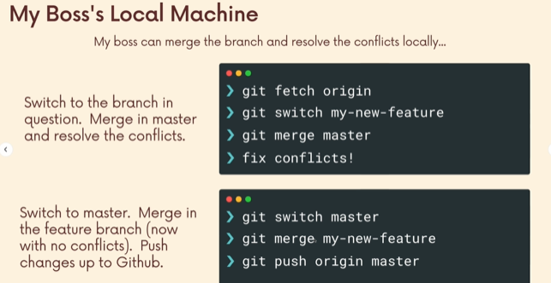
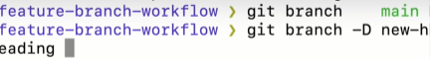

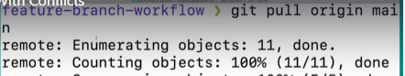

Configuring Branch protection Rules
Goto settings, if you are somebody who have access to setting on a repository.
Lets say you have main and master, if you want main to be “source of truth/ official branch”.
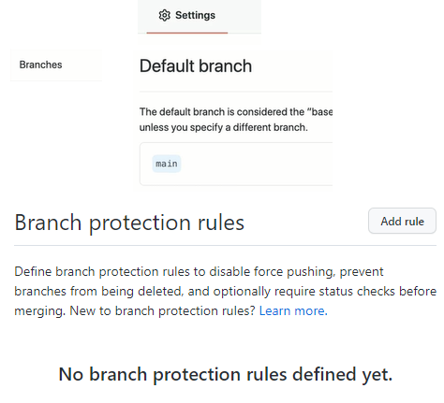

Since, there can be 1000s of branches. Organization enforce rules.
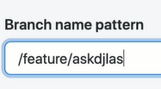
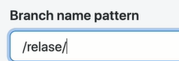

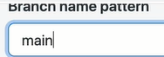

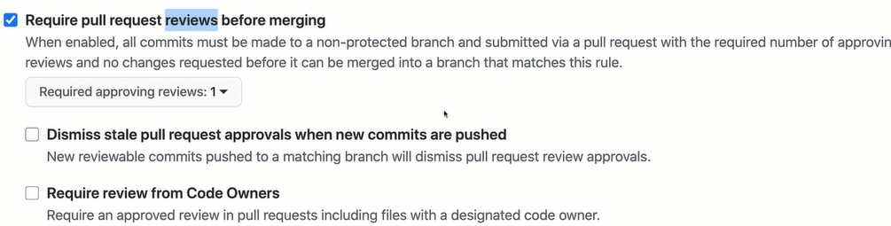

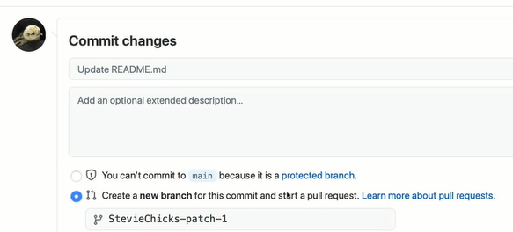

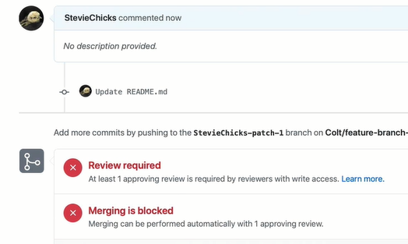

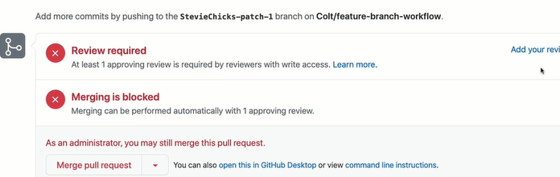
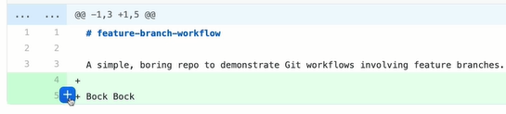

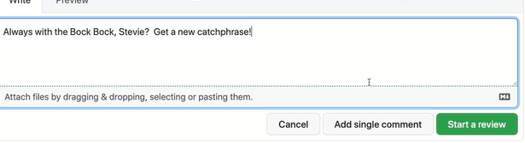
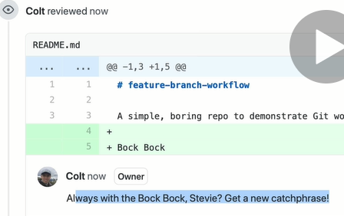

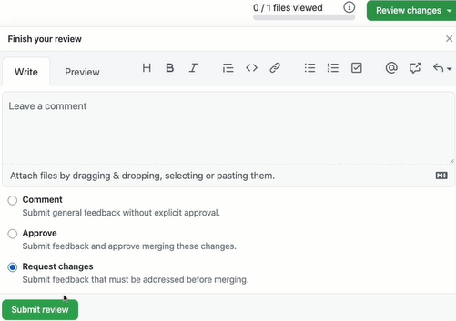

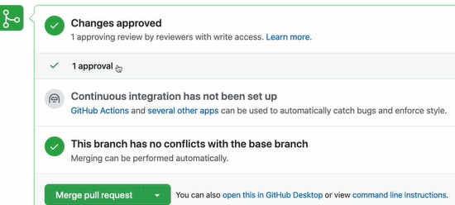
It was just 1 person is approved. Its not merge. There is even more fancy permission if we have organization setup or enterprise account.

